Steps to change your personal settings from your inbox

- Login to your INBOX using web mail.
- Click Options from the top menu
- Click Personal Information from the left side menu
- Click Edit your Identities and you will see the below given screen. Type in the required info. Your full name will be display name for your e-mails. (When you send a mail, others will see your mail in their inbox with your full name.). Other options like signature etc are optional.
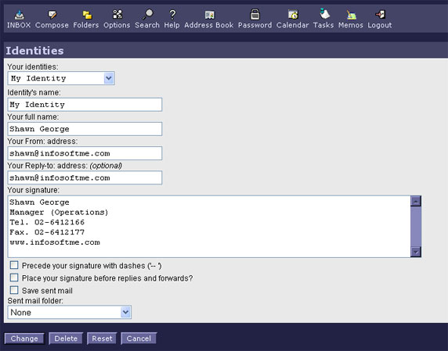

- Click Create when you finish.
- Again Click Options from top menu.
- Click Personal Information
- Select your newly created identity as given in the picture.
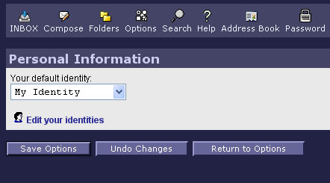
- Click Save Options to save your settings.

