How to apply filter rules

- Open your web mail by typing webmail.yourdomain.com in your browser and enter login details (e-mail user name & password) in the blue screen.
- After successful login, you will be taken to your inbox where you can see your e-mails and many options like INBOX, Compose, Folders, and Options etc. at the top.
- Select ‘Options’ from the menu.
- Click ‘Maintenance Operations’ from the given options.
- Select the following options as per the given picture below. Type 1 for the number of days for message purging. Click Save Options
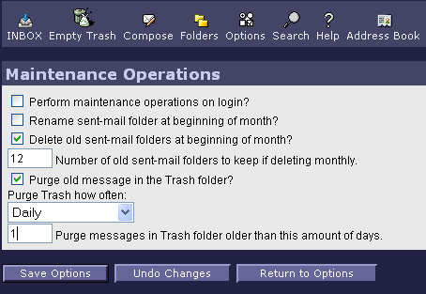
- From the Options click Filter rules and Edit Filter Rules.
- In the Rule Definition, select subject text box and type *****SPAM***** in the Text box as given in the below picture.
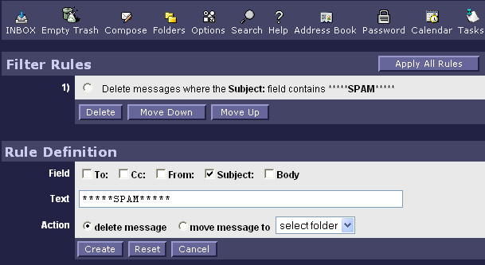
8. Click Create to create that rule. The rule will appear at the top as given in the above picture.
9. Also you can type any particular unwanted e-mail address in the Text box and select the From tick box to avoid that mail coming to your mail box.
10. After creating your custom rules Click Apply All Rules.
11. From the Options click Deleting and moving messages.
12. Select the option as per the below given picture
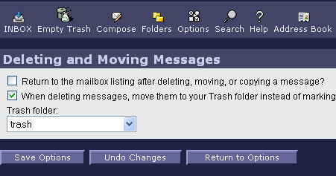
Note: First time you may find Create new Trash instead of trash in the list box.
13. Click Save Options and go back to inbox.

These options will help you to delete unwanted SPAMs when they reach your inbox. Also the automatic empty thrash option will empty the unwanted files automatically.

