Configuring Mail accounts in Outlook Express
- On the Tools menu, click Accounts.
- In the Internet Accounts dialog box, select Mail tab and click the Add button.
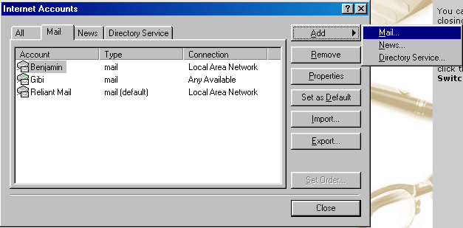
- Select either Mail to open the Internet Connection Wizard, and then follow the instructions.
- Type your name in the Display Name box and click Next.
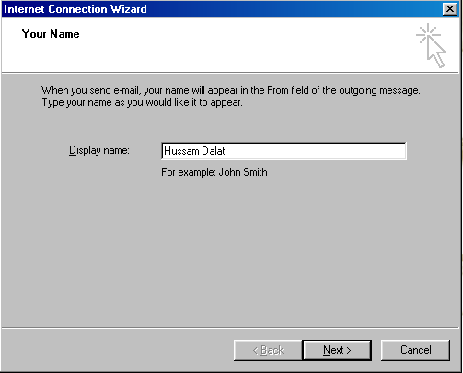
- In Internet E-mail address box, select the first option and type your e-mail address. For example if your username is “hussam”, type hussam@yourdomain.com as your E-mail address. Click Next to proceed.
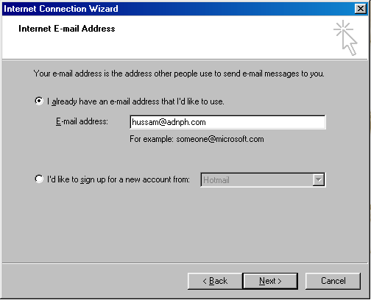

In E-mail Server Names box, Select POP3 as Incoming Mail Server. Type mail.yourdomainname.com as Incoming POP3 server and Outgoing (SMTP) server. 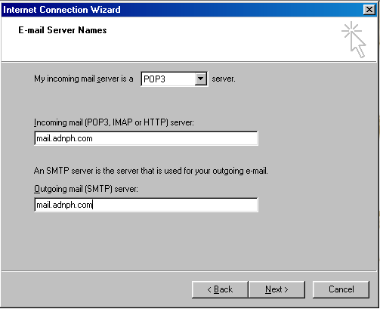

7. In the Internet Mail Logon box, Type your user name and password ( Username will be the first 5 characters of your domain name + first 5 characters of your e-mail account name). If you like the system to remember the password check Remember password box.

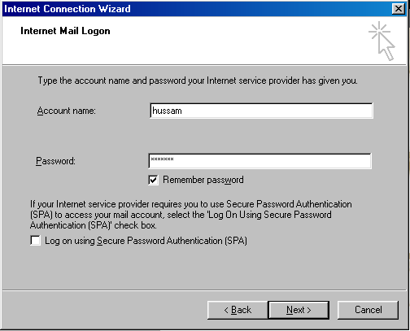

8. Click Finish to save the settings.

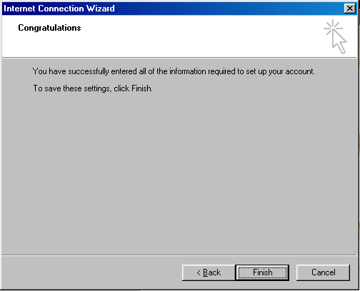

9. The new account will appear as mail.yourdomain.com. Select the account and click properties to rename.

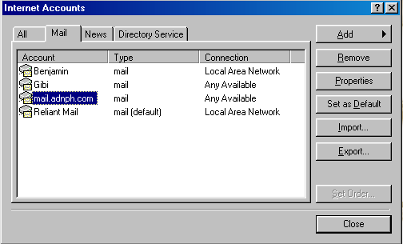

10. In the Properties box, Type your name (or the name you want to refer that account) instead of mail.yourdomain.com and click Apply. Click Ok to close the dialog box. Click close to close the Accounts box.

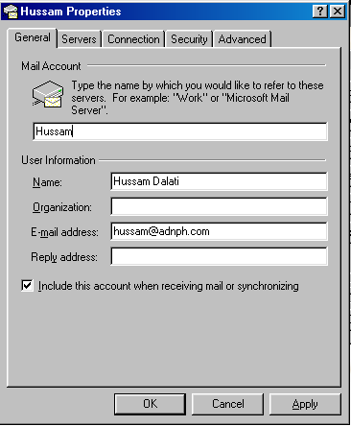

Tips
- Each user can create multiple mail or news accounts by repeating the procedure above for each account.
- You can get a free mail account from Hotmail, which uses HTTP servers.
To check Mail
To check the mail open Outlook Express and select Send and Receive from the Tools menu and click the required account name. You may asked for the username and password to verify for the first time. The mails will be downloaded to your inbox.

----------------------------------

